Database Task

insert into Department (Id,DepartmentNumber,DepartmentType)

Values(newid(),1,'Bones')

insert into Department (Id,DepartmentNumber,DepartmentType)

Values(newid(),1,'Bones')

insert into Department (Id,DepartmentNumber,DepartmentType)

Values(newid(),2,'Bones')

insert into Department (Id,DepartmentNumber,DepartmentType)

Values(newid(),3,'Regular')

insert into Department (Id,DepartmentNumber,DepartmentType)

Values(newid(),4,'Bones')

insert into Department (Id,DepartmentNumber,DepartmentType)

Values(newid(),5,'FastResponse')

insert into Department (Id,DepartmentNumber,DepartmentType)

Values(newid(),6,'Bones')

insert into Department (Id,DepartmentNumber,DepartmentType)

Values(newid(),7,'FastResponse')

insert into Department (Id,DepartmentNumber,DepartmentType)

Values(newid(),8,'Bones')

insert into Department (Id,DepartmentNumber,DepartmentType)

Values(newid(),9,'Regular')

insert into Department (Id,DepartmentNumber,DepartmentType)

Values(newid(),10,'Regular')

-----Hospital

insert into Hospital (Id,Address,Name)

Values(newid(),'Tallinn','Saint Juves')

insert into Hospital (Id,Address,Name)

Values(newid(),'Harjumaa','Harjumaa Haigla')

insert into Hospital (Id,Address,Name)

Values(newid(),'Mustamäetee','Tallinna Haigla')

insert into Hospital (Id,Address,Name)

Values(newid(),'Kiili','Kiili Haigla')

insert into Hospital (Id,Address,Name)

Values(newid(),'Mustamäetee','Saint Juves')

insert into Hospital (Id,Address,Name)

Values(newid(),'Mustamäetee','Mustamäe Haigla')

insert into Hospital (Id,Address,Name)

Values(newid(),'Tallinn','Tallina Haigla')

insert into Hospital (Id,Address,Name)

Values(newid(),'Tartu','Tartu Haigla')

insert into Hospital (Id,Address,Name)

Values(newid(),'RandomAddress','Pärnu haigla')

insert into Hospital (Id,Address,Name)

Values(newid(),'Random','Saint Juves')

----Nurse

insert into Nurse(Id,FirstName,LastName,Email)

Values(newid(),'Desislava','Rein','Desislava@Rein.com')

insert into Nurse(Id,FirstName,LastName,Email)

Values(newid(),'Margret','Marcella','Margret@Marcella.com')

insert into Nurse(Id,FirstName,LastName,Email)

Values(newid(),'Gaia','Paulo','Gaia@Paulo.com')

insert into Nurse(Id,FirstName,LastName,Email)

Values(newid(),'Chikumbutso','Slávka','Chikumbutso@Slávka.com')

insert into Nurse(Id,FirstName,LastName,Email)

Values(newid(),'Petra',' Geghard','Petra@Geghard.com')

insert into Nurse(Id,FirstName,LastName,Email)

Values(newid(),'Kawacatoose ','Stefania','Kawacatoose@Stefania.com')

insert into Nurse(Id,FirstName,LastName,Email)

Values(newid(),'Almast ','Swarna','Almast@Swarna.com')

insert into Nurse(Id,FirstName,LastName,Email)

Values(newid(),'Hwan','Gaiana','Hwan@Gaiana.com')

insert into Nurse(Id,FirstName,LastName,Email)

Values(newid(),'Shiva','Turin','Shiva@Turin.com')

insert into Nurse(Id,FirstName,LastName,Email)

Values(newid(),'Cerere','Eleutério','Cerere@Eleutério.com')

----Patient

select \* from Patient

insert into Patient(Id,Name,TelephoneNumber,DateOfBirth,Address,PatientPresence)

values(newid(),'Karl',677-3556,'09/28/96','3296 Lamberts Branch Road','Present')

insert into Patient(Id,Name,TelephoneNumber,DateOfBirth,Address,PatientPresence)

values(newid(),'Martin',370-9259,'10/17/05','953 Marshall Street','Present')

insert into Patient(Id,Name,TelephoneNumber,DateOfBirth,Address,PatientPresence)

values(newid(),'Mihkel',379-9597,'11/27/19','4622 Bassel Street','Absent')

insert into Patient(Id,Name,TelephoneNumber,DateOfBirth,Address,PatientPresence)

values(newid(),'Hendrik',280-7751,'12/01/20','3315 Rodney Street','Present')

insert into Patient(Id,Name,TelephoneNumber,DateOfBirth,Address,PatientPresence)

values(newid(),'Hendri',455-4673,'11/12/18','529 Willis Avenue','Absent')

insert into Patient(Id,Name,TelephoneNumber,DateOfBirth,Address,PatientPresence)

values(newid(),'Joosep',407-5233,'10/16/06','1628 Hillcrest Avenue','Absent')

insert into Patient(Id,Name,TelephoneNumber,DateOfBirth,Address,PatientPresence)

values(newid(),'Kalev',735-9684,'03/18/07','532 Peaceful Lane','Present')

insert into Patient(Id,Name,TelephoneNumber,DateOfBirth,Address,PatientPresence)

values(newid(),'Margus',724-3368,'03/06/03','2684 Spinnaker Lane','Absent')

insert into Patient(Id,Name,TelephoneNumber,DateOfBirth,Address,PatientPresence)

values(newid(),'Hannes',467-0505,'03/29/10','304 Locust Street','Present')

insert into Patient(Id,Name,TelephoneNumber,DateOfBirth,Address,PatientPresence)

values(newid(),'Martin',782-5695,'06/01/14','1243 Milford Street','Absent')

----ward

insert into Ward(Id,WardRoomNumber,WardBedAmount)

values(newid(),1,10)

insert into Ward(Id,WardRoomNumber,WardBedAmount)

values(newid(),2,5)

insert into Ward(Id,WardRoomNumber,WardBedAmount)

values(newid(),3,4)

insert into Ward(Id,WardRoomNumber,WardBedAmount)

values(newid(),4,2)

insert into Ward(Id,WardRoomNumber,WardBedAmount)

values(newid(),5,15)

insert into Ward(Id,WardRoomNumber,WardBedAmount)

values(newid(),6,17)

insert into Ward(Id,WardRoomNumber,WardBedAmount)

values(newid(),7,25)

insert into Ward(Id,WardRoomNumber,WardBedAmount)

values(newid(),8,10)

insert into Ward(Id,WardRoomNumber,WardBedAmount)

values(newid(),9,22)

insert into Ward(Id,WardRoomNumber,WardBedAmount)

values(newid(),10,19)

----Stored Proc

CREATE PROCEDURE SelectAllPatientsPresence @Name nvarchar(30),@PatientPresence nvarchar(20)

AS

SELECT \* FROM Patient WHERE Name=@Name AND PatientPresence=@PatientPresence

GO

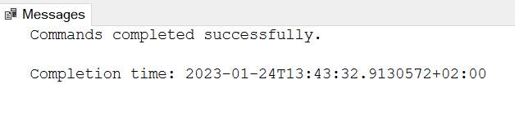

EXEC SelectAllPatientsPresence @Name='Martin',@PatientPresence='Absent'



SELECT Patient.Id,Patient.Name,Patient.TelephoneNumber,Patient.DateOfBirth,Patient.Address,Patient.PatientPresence,Hospital.Name

from Patient

full JOIN Hospital

on Patient.Name=Hospital.Name;

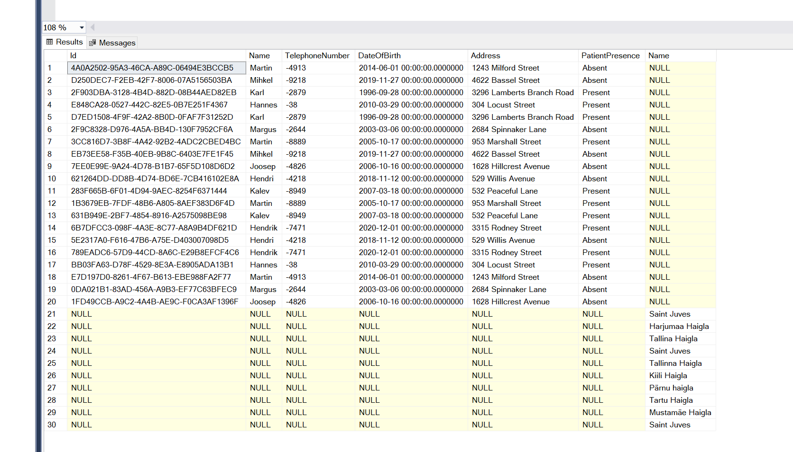

SELECT Patient.Id,Patient.Name,Patient.TelephoneNumber,Patient.DateOfBirth,Patient.Address,Patient.PatientPresence,Nurse.Id

from Patient

left join Nurse

on Patient.Id=Nurse.Id

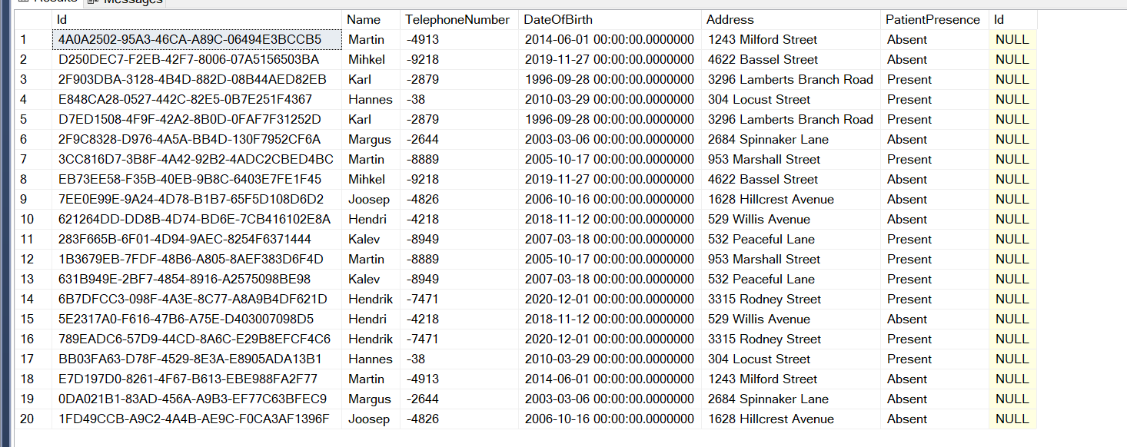

SELECT Department.Id,Department.DepartmentNumber,Department.DepartmentType

from Department

Right join Ward

on Department.DepartmentNumber=Ward.WardRoomNumber

